**What is the difference between findElement and findElements in Selenium WebDriver?**

<https://www.youtube.com/watch?v=NInJVd6aBKM>

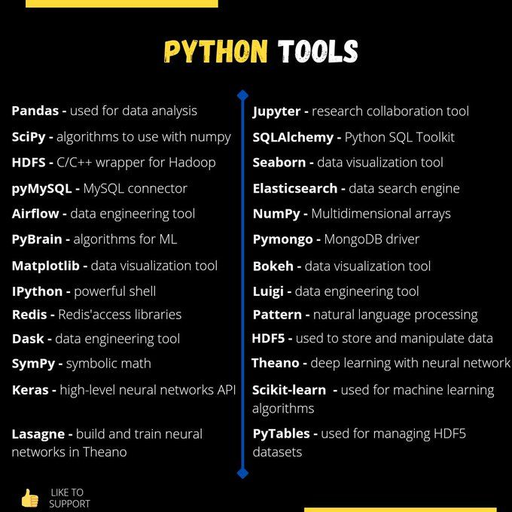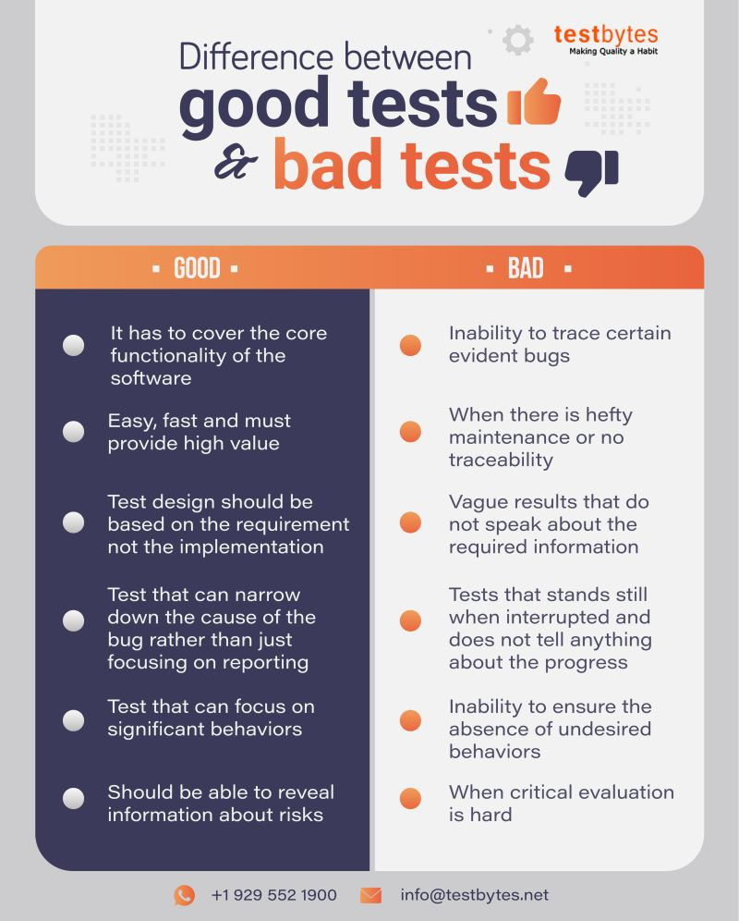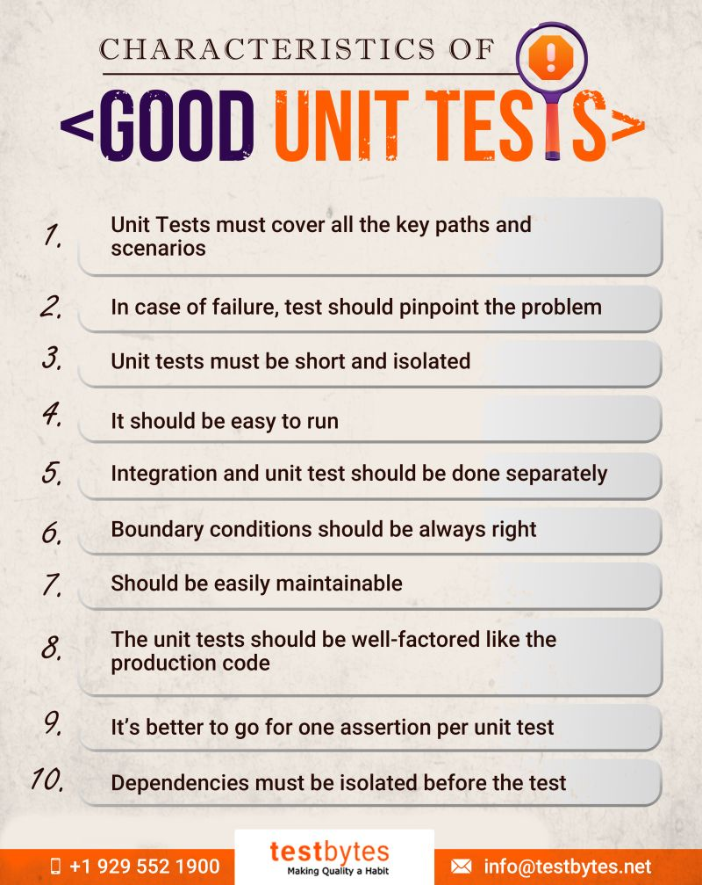

<https://www.linkedin.com/feed/update/urn:li:activity:6845944898483552256/?updateEntityUrn=urn%3Ali%3Afs_feedUpdate%3A%28V2%2Curn%3Ali%3Aactivity%3A6845944898483552256%29>

I recently learned about the python package TQDM and I am excited to begin to use it.   
  
The package creates a progress bar for any iterable you wrap it with, and shows you how many iterations per second the loop performs. It’s a pretty well known package with 19.5k stars on Github but I thought I would share it in case you had not heard of it, like me.   
  
TQDM would have been useful in previous projects of mine with large datasets, where I wasn’t sure if my code contained an infinite loop or if it was just taking a long time to iterate. I am always trying to write more efficient code, so I am happy I came across the TDQM package to quantify the speeds of my loops.



<https://www.linkedin.com/feed/update/urn:li:activity:6843482898994229248/?updateEntityUrn=urn%3Ali%3Afs_feedUpdate%3A%28V2%2Curn%3Ali%3Aactivity%3A6843482898994229248%29>

How often do we talk about the importance of database unit testing?   
  
No matter if you are the only database person in your company or if there are 1000 people. No matter if you have one database or 1000 databases.   
  
The application of unit testing allows you to ensure that once you write something, it can be verified, and then when it needs to change, you can verify that all of the previously passed tests will continue to pass.   
  
That will give you confidence that your changes will be more accurate and less likely to break other things that rely on your code. And after all, that will inevitably help you sleep at night, enjoy your vacations more and be more confident in what you develop.  
  
What database testing tools can my QA team recommend? Swipe on the photo

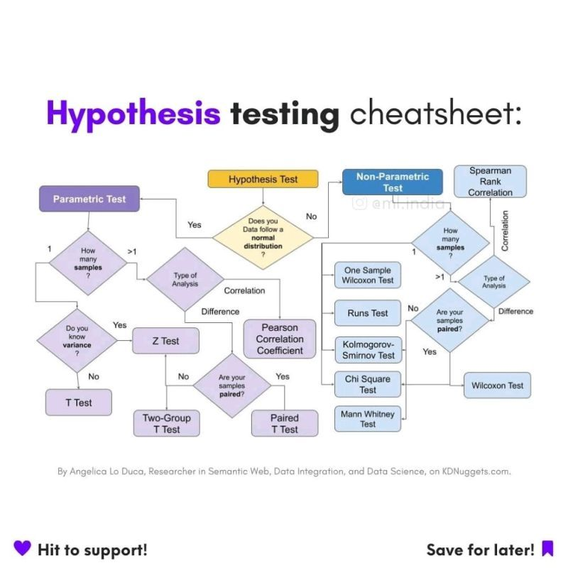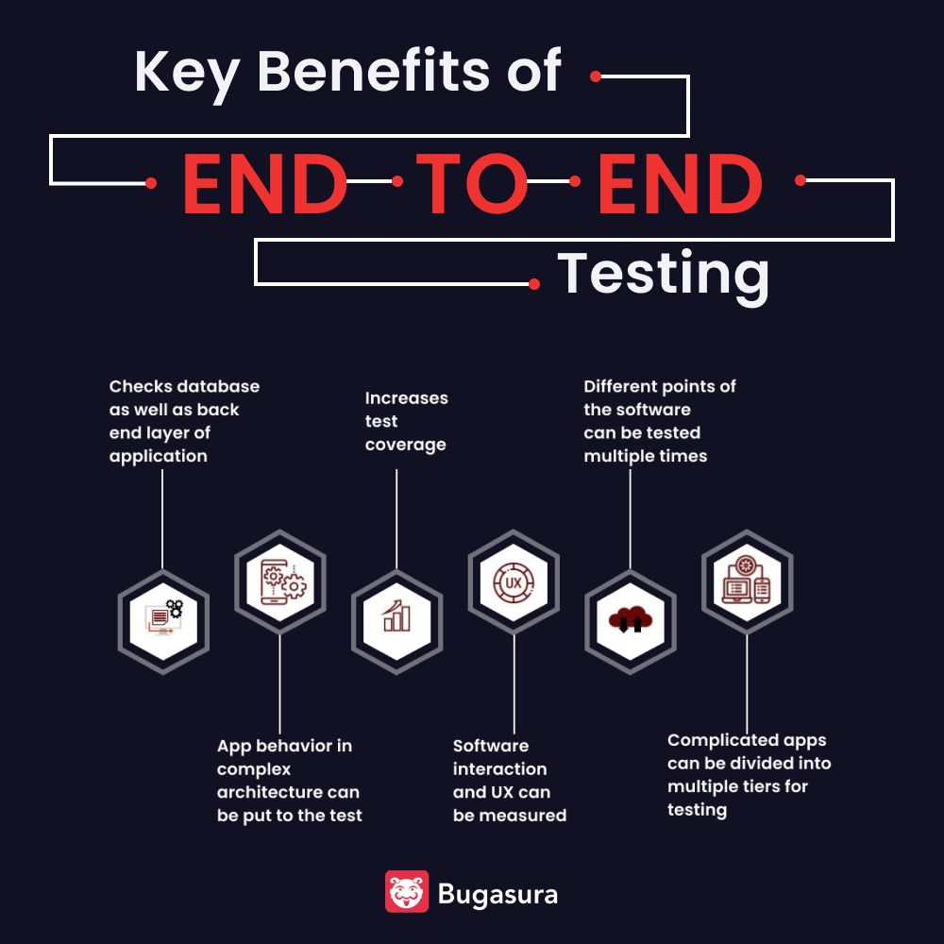

Testing is an important phase of the software development life cycle. The more regress and more extensive the testing is, the lesser are the chances of defects and software breakdown. The defects in the end products are not only because of the functional part of the application but can also arise because of the system and sub-systems integration, error in the back-end database, etc. As a result, you require the assistance of end to end testing.

<https://www.linkedin.com/feed/update/urn:li:activity:6844425940697780224/?updateEntityUrn=urn%3Ali%3Afs_feedUpdate%3A%28V2%2Curn%3Ali%3Aactivity%3A6844425940697780224%29>

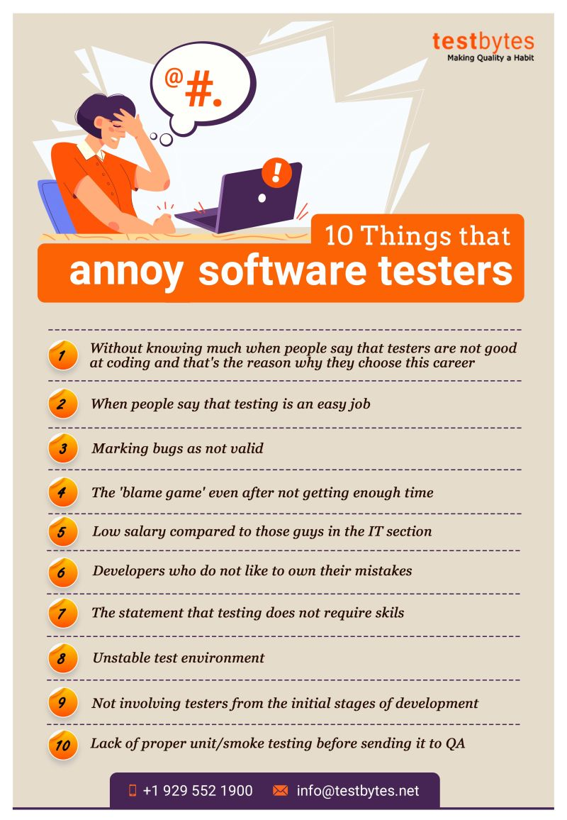

<https://www.linkedin.com/feed/update/urn:li:activity:6842790680356626432/?updateEntityUrn=urn%3Ali%3Afs_feedUpdate%3A%28V2%2Curn%3Ali%3Aactivity%3A6842790680356626432%29>

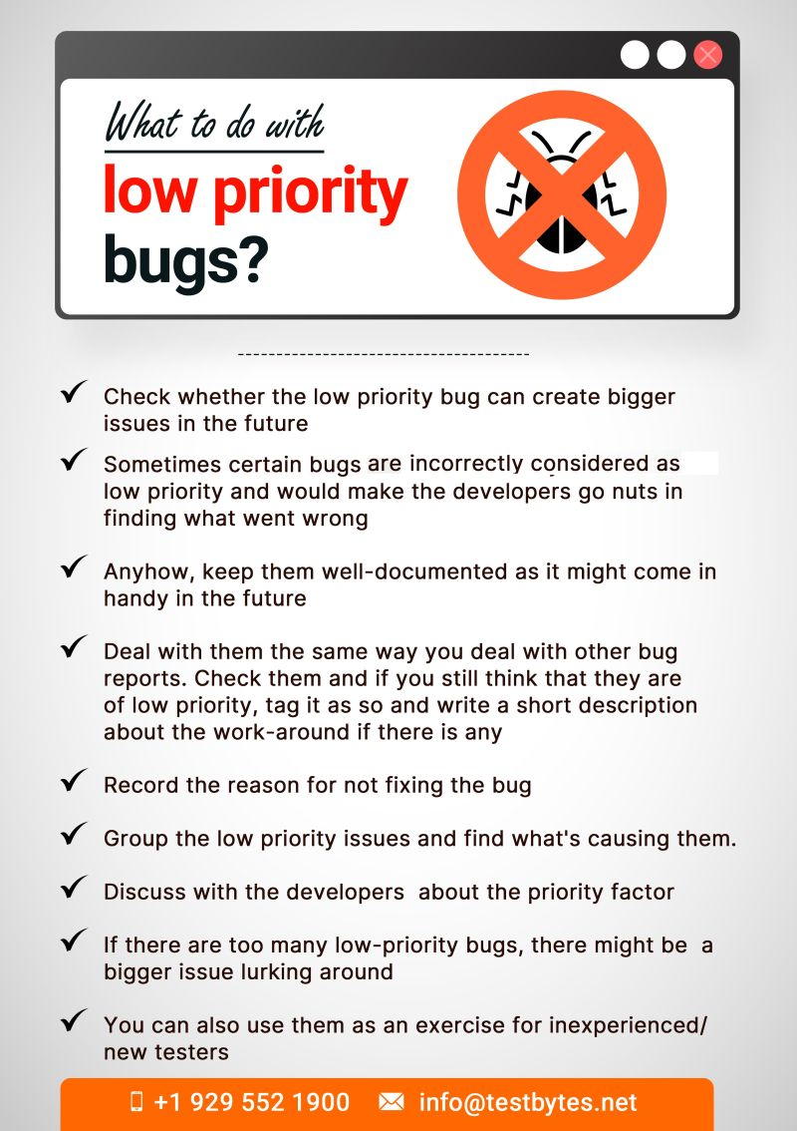

<https://www.linkedin.com/feed/update/urn:li:activity:6840863145402204160/?updateEntityUrn=urn%3Ali%3Afs_feedUpdate%3A%28V2%2Curn%3Ali%3Aactivity%3A6840863145402204160%29>

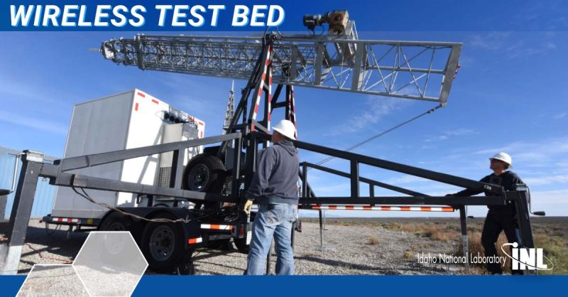

Idaho National Laboratory offers one of the nation’s premier wireless test beds accessible to academia, industry and government organizations.   
  
Users can demonstrate new and emerging wireless technologies and develop and train to tactics, techniques, and procedures in an environment with configurations at real frequency and power levels.   
  
Learn more about INL's wireless test bed capabilities, expertise and emerging research: <https://lnkd.in/gyNU7D9j>

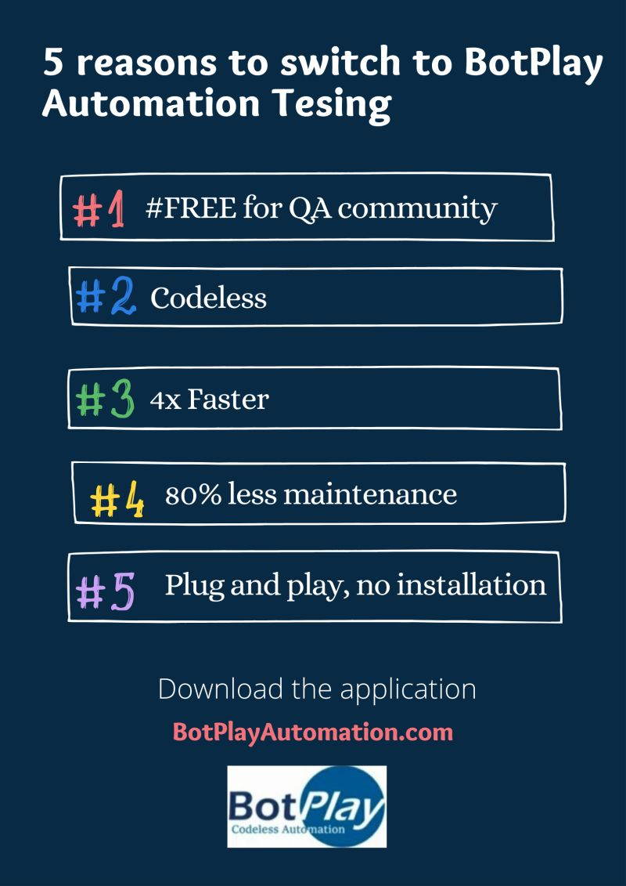

Starting [#automation](https://www.linkedin.com/feed/hashtag/?keywords=automation&highlightedUpdateUrns=urn%3Ali%3Aactivity%3A6838328298381082624) testing? FIVE cool reasons to start using [#BotPlay](https://www.linkedin.com/feed/hashtag/?keywords=botplay&highlightedUpdateUrns=urn%3Ali%3Aactivity%3A6838328298381082624).  
Download now - [botplayautomation.com](http://botplayautomation.com)

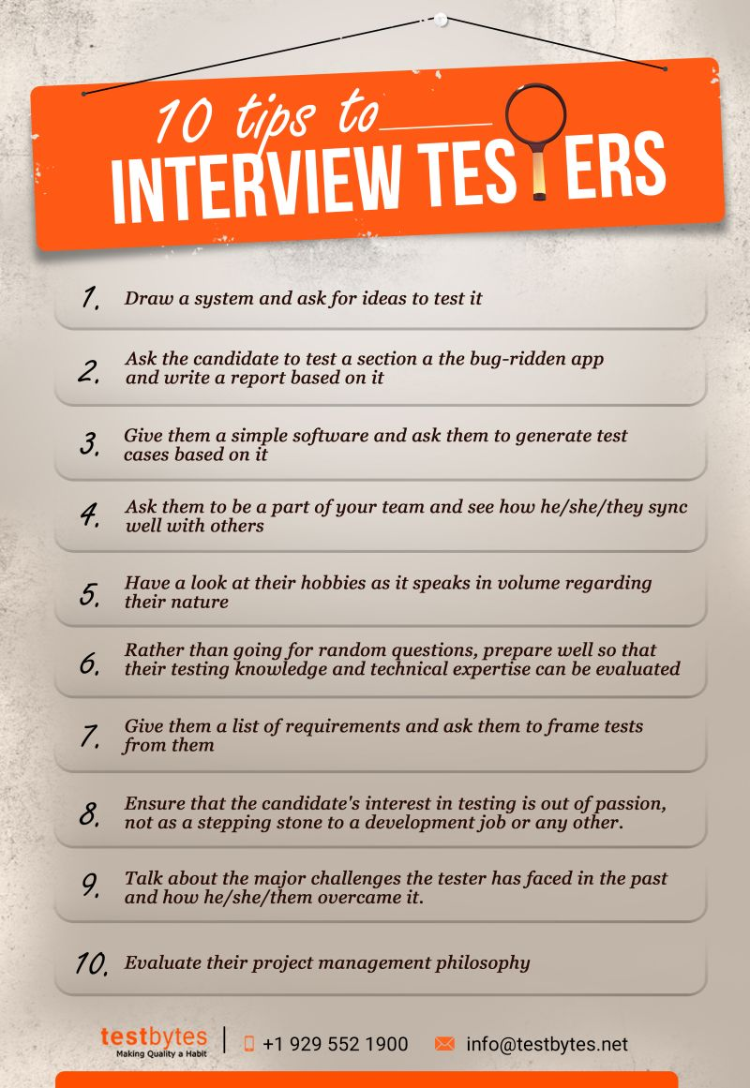

We hope these tips can help you in choosing the right person for your team. Feel free to add more points in the comment section  
For more infographics--> <https://lnkd.in/gQXGyWh>

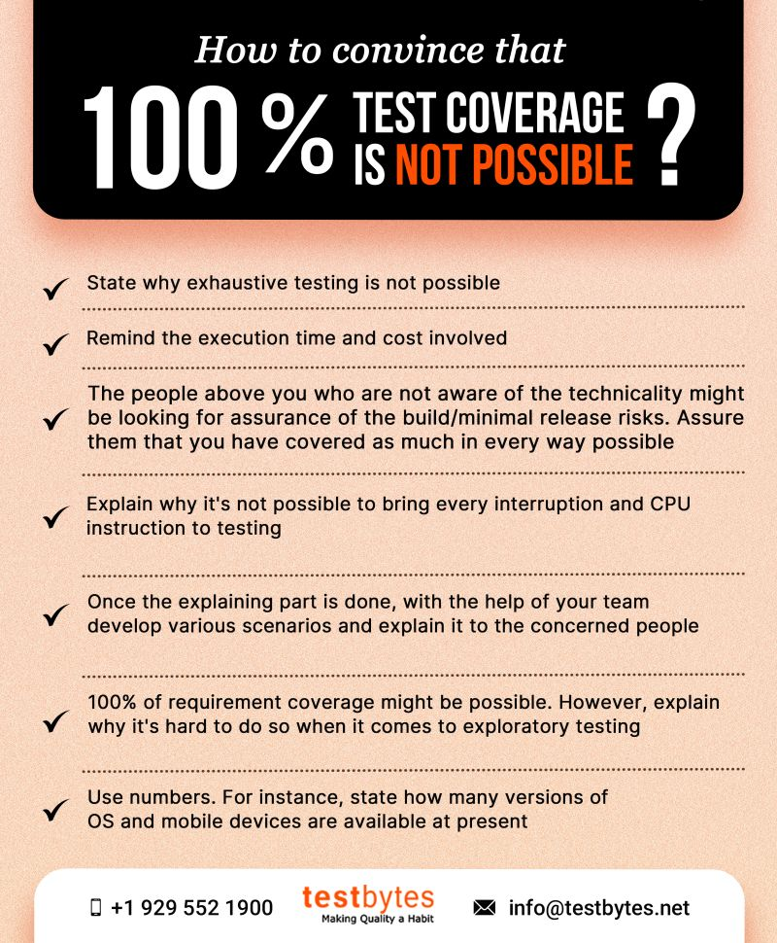Your boss is asking for 100% test coverage. Here are some ways you can convince that it's not possible.   
For more infographics---> <https://lnkd.in/gQXGyWh>

